Marc Beutner / Rasmus Pechuel (Ed.)
  - E-Learning, Digitisation and Units for Learning at VET schools –
  - Creating Online Learning Environments in Technical Education for
  - European metal industry

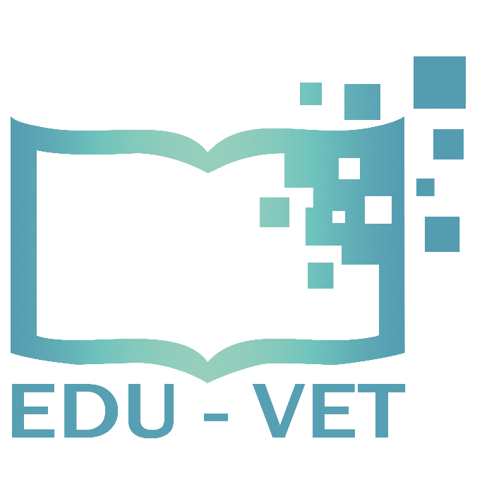
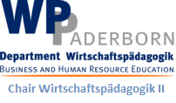
IK-Verlag
8888

  - New Opportunities and Challenges
for European VET schools in metal industry
  - Insights in the EDU-VET Project

The EDU-VET project, addressed in this book, is co-funded by the ERASMUS+ programme of the European Union The European Commission is not responsible for any uploaded or submitted content. Such content expresses the views of its author(s) only.

Bibliographische Information Der Deutschen Bibliothek

Die Deutsche Bibliothek verzeichnet diese Publikation in der Deutschen Nationalbibliographie; detaillierte bibliographische Daten sind im Internet verfügbar über:
http://dnb.ddb.de abrufbar.

ISBN:
1. Aufl. 2022
© Lehrstuhl Wirtschaftspädagogik II, Universität Paderborn

und
©

Ingenious Knowledge Verlag
Hausanschrift: Gottfried-Hagen-Straße 60-62, 51105 Köln
Telefon: (0221) 16820019
Köln, März 2022
Alle Rechte, auch auszugsweisen Nachdrucks, der fotomechanischen Wiedergabe (einschließlich Mikrokopie) sowie die Auswertung durch Datenbanken vorbehalten.

EDU-VET and E-Learning – an introduction
Marc Beutner
Digital transformation has influence on our daily life (Beutner / Pechuel / Schneider 2021). Accelerating economy and businesses it often transcends traditional roles of staff members, costumers but also learners. It is based on changes concerning aspects of culture, processes and technology as well as data requirements (see similar idea at Davenport / Reman 2020, p. 1) and it effects our society in different fields: e.g. economy, social interaction and education.
“Digital transformation and innovation in digitalization are boosted by consumers’ and investors’ expectations, as well as by prospects of greater economic and social benefits. Much of the literature claims that successful digital transformation comes not only from implementing new technologies, but also from transforming the organizations to take advantage of the possibilities that new technologies provide.” (Schilirò 2020, p. 3).
With this book we will have a closer look at possibilities in the field of digital education as it is provided within the EDU-VET project which focuses education for metal industry.
A core aspect is the fact that digital education “is all about using digital technologies and tools in an innovative manner to teach and learn.” (SkoolBeep 2022, p 1.)
The Digital Education Action Plan of the European Commission states that the “education and training system is increasingly part of the digital transformation and can harness its benefits and opportunities.” (European Commission 2020, p. 2)
The Commission points out that:
“Transforming education for the digital age is a task for the whole society. […]
Digital education should play a pivotal role in increasing equality and inclusiveness. […]
Digital competence should be a core skill for all educators and training staff.”
(European Commission 2020, p. 8)
One of the most crucial aspects addressed by the Commission in its digital action plan is the fact that:
“Digital literacy is essential for life in a digitalised world“ (European Commission 2020, p. 9)
and the idea that
“Being digitally skilled and acquiring digital literacy can empower people of all ages to be more resilient, improve participation in democratic life and stay safe and secure online” (European Commission 2020, p. 12).
Moreover, the Commission adds:
“In addition to digital skills, the digital economy requires also complementary skills such as adaptability, communication and collaboration skills, problem-solving, critical thinking, creativity, entrepreneurship and readiness to learn” (European Commission 2020, p. 12).
Taking this into account EDU-VET decided to adjust eLearning in the field of metal works to the current needs and opportunities of digital education. New processes as well as technical and personal skills are gaining in importance in this sector. Today's students need to be prepared for more flexible forms of work and with regard to EDU-VET of metal work. Leaners face a more flexible labour market. This also leads to more mobility and dynamic work biographies. This also means that the metal sector needs educational resources that can be adjusted to varying contexts. Integrating different competence levels offers opportunities to accelerate reskilling and upskilling in personalised learning processes. Kasraie / Kasraie define eLearning very general “as learning facilitated through electronic means.” (Kasraie / Kasraie 2010, p. 57)
Other authors focus more on the aspect of pedagogy and didactics which is needed to deal with elearning but highlight the technology aspect within. For example, Tirade et al. define elearing as "pedagogy empowered by digital technology” (Titrade, El Baaboua, Sion, & Mihalcescu, 2009).
A specific aspect of eLearning can be found in the processes in which digital technologies are used by educators to design pedagogic fruitful and engaging learning environments. In EDU-VET the focus of eLearning is set with regard to blended learning approaches which are fostered by a learning platform with courses designed with regard to different competence levels. Blended learning approaches can be offered by different models of types. In EDU-VET we offer opportunities to use our developed course system within the different approaches based on the types of blended learning addressed by Staker and Horn.
Blended approaches are a mixture of face-to-face learning and digital learning which today often takes place online. Often a core idea is to combine inquiry-based learning, self-directed learning and social learning (see e.g. TeachThought Staff / Olsen 2013)
Already in 2012 Staker and Horn offered an overview on types of blended learning and differentiated between (a) rotation models, like the station-rotation model, the lab-rotation model, the flipped-classroom model and the individual-rotation model, (b) the flex model, (c) the self-blend model and (d) the enriched-virtual model (Staker / Horn 2012, p. 2)
They describe a rotation model as “a program in which within a given course or subject (e.g., math), students rotate on a fixed schedule or at the teacher’s discretion between learning modalities, at least one of which is online learning.” (Staker / Horn 2012, p. 8).
The flex model is “a program in which content and instruction are delivered primarily by the Internet, students move on an individually customized, fluid schedule among learning modalities, and the teacher-of-record is on-site.” (Staker / Horn 2012, p. 12).
Moreover, the self-blend model “describes a scenario in which students choose to take one or more courses entirely online to supplement their traditional courses and the teacher-of-record is the online teacher.” (Staker / Horn 2012, p. 14).
And the enriched-virtual model is seen as a “a whole-school experience in which within each course (e.g. math), students divide their time between attending a brick-and-mortar campus and learning remotely using online delivery of content and instruction.” (Staker / Horn 2012, p. 15).
The goal of blended learning and also of the EDU-VET project is not to replace conventional learning styles or environments. We rather look for possibilities to incorporate useful opportunities and to complement face-to-face and online learning activities. The core idea is to foster the learners and support personalized the educational paths for learners.
This recognises a crucial aspect raised by European Parliamentary Research Service with regard to the fields of education addressed by the CEDEFOP:
“For the field of education, defined as encompassing school education, vocational training and higher education (Cedefop 2019[…]), this implies that facts no longer have to be learned by heart – instead, they can beimmediately accessed using mobile devices.” (European Parliamentary Research Service 2020, p.1)
Digital education offers the chance to rethink traditional learning process and to integrate aspects of the transformation process which happens in economy and our daily life also in education. This goes hand in hand with new option to make education more mobile, engaging, and interactive.
Marc Beutner
Paderborn, February 2022
References
Beutner, M. / Rasmus Pechuel / Jennifer Schneider (2021): Fostering Digitisation and Industry 4.0: Education – Vocation - Industry – Future. New Opportunities and Challenges for European VET. Insights in the DigI-VET Project. Köln 2021.
Davenport, T. H. / Reman, T. C. (2020): Digital Transformation Comes Down to Talent in 4 Key Areas. In: Harvard Business Review. Technology and analytics. Retrieved from the internet: https://hbr.org/2020/05/digital-transformation-comes-down-to-talent-in-4-key-areas, Accessed: 05.01.2022.
European Commission (2020): Digital Education Action Plan. 2021-2027. Resetting education and training for the digital age. Retrieved from the internet: https://ec.europa.eu/education/sites/education/files/document-library-docs/deap-communication-sept2020_en.pdf, Accessed: 05.01.2022.
European Parliamentary Research Service (2020): Rethinking education in the digital age. Study. Panel for the Future of Science and Technology. Retrieved from the internet: https://www.europarl.europa.eu/RegData/etudes/STUD/2020/641528/EPRS_STU(2020)641528_EN.pdf, Accessed: 01.02.2022.
Kasraie, N. / Kasraie, E. (2010): Economies Of Elearning In The 21st Century. In: Contemporary Issues In Education Research – October 2010, Vol. 3, No. 10, p. 57-62.
Schilirò, D. (2020): Towards digital globalization and the covid-19 challenge. MPRA Paper No. 100504. MPRA: Munich May 2002.
SkoolBeep (2022): How Digital Learning is Changing the Face of Education? Retrieved from the internet: https://www.skoolbeep.com/blog/how-digital-learning-is-changing-the-face-of-education/, Accessed: 01.02.2022.
Staker, H., & Horn, M. B. (2012). Classifying K-12 blended learning. Innosight Institute.
TeachThought Staff / Olsen, R. (2013): The Principles Of Modern Learning. Retrieved from the internet: https://www.teachthought.com/the-future-of-learning/principles-modern-learning/, Accessed: 01.02.2022.
Titrade, C., El Baaboua, F., Sion, B., & Mihalcescu, C. (2009). E-Learning. Annals of the University of Oradea, Economic Science Series, 18(4),1066-1069.

